Associate Data Analyst
Accenture, India
Senior Data Analyst
Accenture, India
Data Analyst
Accenture, India

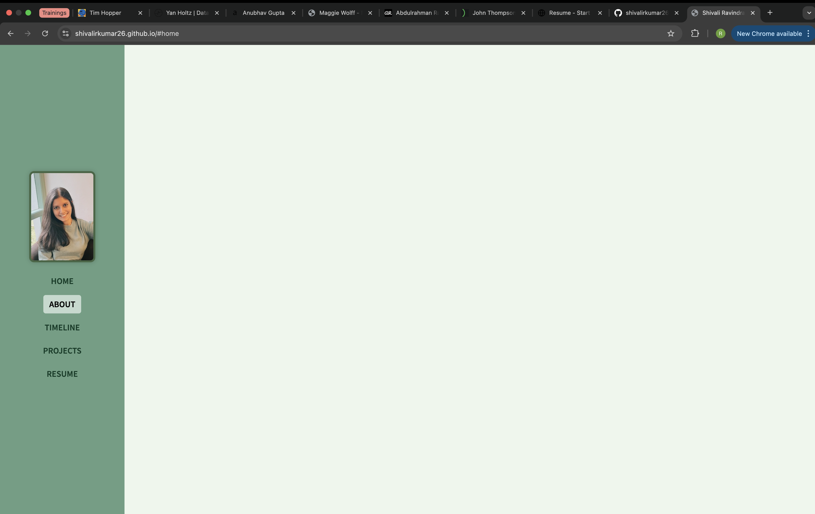
SHIVALI RAVINDRA KUMAR
 Esslingen am Neckar, Germany
 +49 172 8768128
 shivali.ravindrakumar@gmail.com

<PLACE ABOUT TEXT HERE…>



Welcome!
I’m Shivali, a data professional with a curious mind and a love for meaningful work.
Over the last four years, I’ve worked on turning numbers into narratives — helping teams make informed, confident decisions.
Beyond analytics, I enjoy building tools, streamlining workflows, and solving real problems with simple, elegant solutions.
This portfolio brings together my experiences, projects, and a glimpse into how I think.

HOME
ABOUT
TIMELINE
PROJECTS
RESUME
Insert my photo here

